FAST NUCES
Artificial Intelligence | Spring 2026

Project Report

CineMatch: An Intelligent Movie Recommendation Engine

Tayaba — 24K-0934
Wardah Ahmed — 24K-1045
Humna Fatime — 23K-1016

1. Introduction
CineMatch is a movie recommendation system built on the MovieLens 100K dataset. It combines two recommendation techniques, content-based filtering and collaborative filtering, into a hybrid model that suggests movies a user is likely to enjoy based on both genre similarity and the behavior of other users with similar taste. The system is served through a FastAPI backend and accessed via a Streamlit frontend.

2. Dataset
The MovieLens 100K dataset was sourced from the GroupLens research lab. It contains:
- 100,000 ratings from 943 users across 1,682 movies
- Ratings on a scale of 1 to 5
- 19 genre labels per movie stored as binary flags
- 93.7% sparsity in the user-movie rating matrix

No missing values were found in either the ratings or movie metadata files. The most commonly given rating was 4 out of 5. Star Wars was the most rated movie, and User 405 was the most active with over 700 ratings.
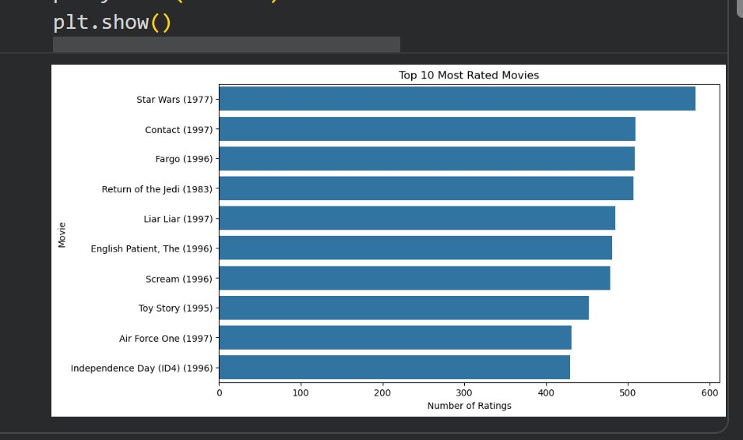
Figure 1: Top 10 Most Rated Movies in the MovieLens 100K Dataset
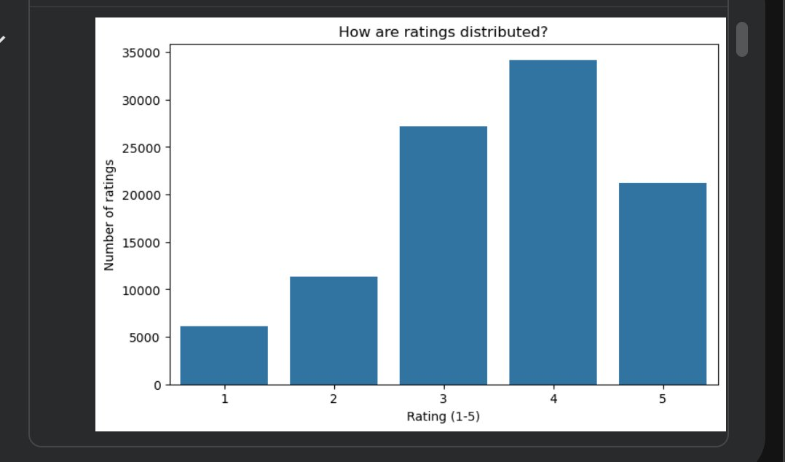
Figure 2: Distribution of Ratings (1–5) Across All 100,000 Ratings
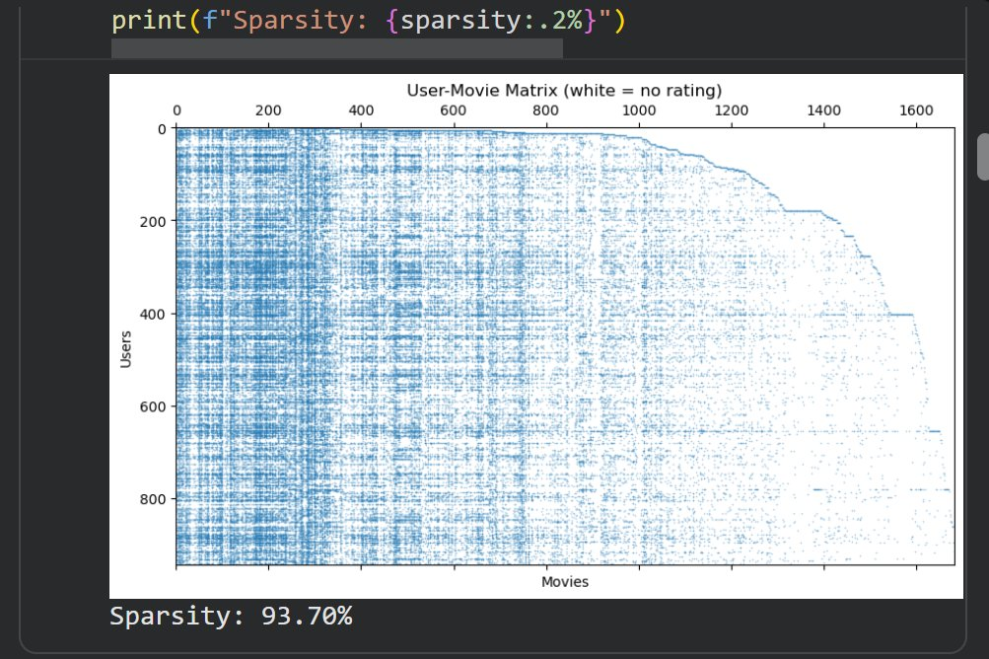
Figure 3: Visualization of the User-Movie Rating Matrix (white = no rating). Sparsity: 93.70%

3. System Architecture
The system is split into two components. The backend is a FastAPI application (app.py) that loads pre-trained models from serialized pickle files and exposes two REST endpoints. The frontend is a Streamlit application (frontend.py) that sends HTTP requests to the backend and renders recommendations with movie posters and ratings fetched from the TMDB API.

3.1 Backend Endpoints

Endpoint | Method | Description
/ | GET | Health check
/recommend | GET | Hybrid recommendations for a given user and movie
/similar | GET | Content-based similar movies for a given title

3.2 Serialized Models
The following pickle files are loaded at startup by the backend:
- cosine_sim.pkl — genre-based cosine similarity matrix (1682 x 1682)
- user_similarity_df.pkl — user-user cosine similarity matrix (943 x 943)
- user_movie_matrix.pkl — sparse user-movie rating pivot table
- movies.pkl and movies_full.pkl — movie metadata and genre vectors

4. Methodology

4.1 Content-Based Filtering
Each movie in the dataset is represented as a binary genre vector across 19 genre categories. Cosine similarity is computed between all pairs of movie vectors, producing a 1682 x 1682 similarity matrix. When a user selects a movie, the system retrieves that movie’s row from the matrix, sorts all other movies by similarity score, and returns the top matches. This approach is genre-only and produces the same results regardless of who the user is.
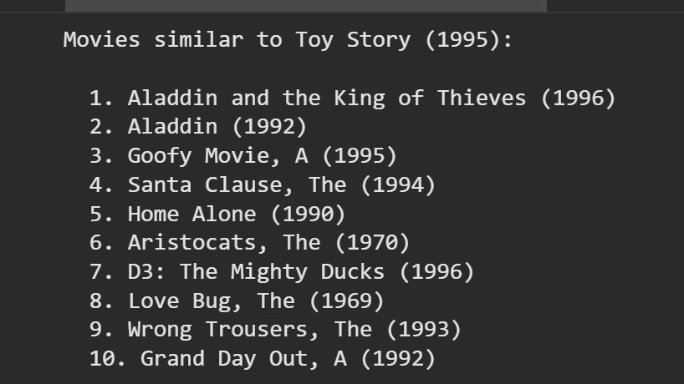
Figure 4: Content-Based Filtering Output — Top 10 Genre-Similar Movies to Toy Story (1995)

4.2 Collaborative Filtering (User-Based)
A user-movie pivot table is constructed with users as rows and movie IDs as columns. Missing ratings are filled with zero. Cosine similarity is then computed between all pairs of users, giving a 943 x 943 similarity matrix. For a given user, the system finds the 50 most similar users, collects movies those users rated 4 or higher that the target user has not yet seen, and scores each candidate movie by summing the similarity-weighted ratings across all similar users.
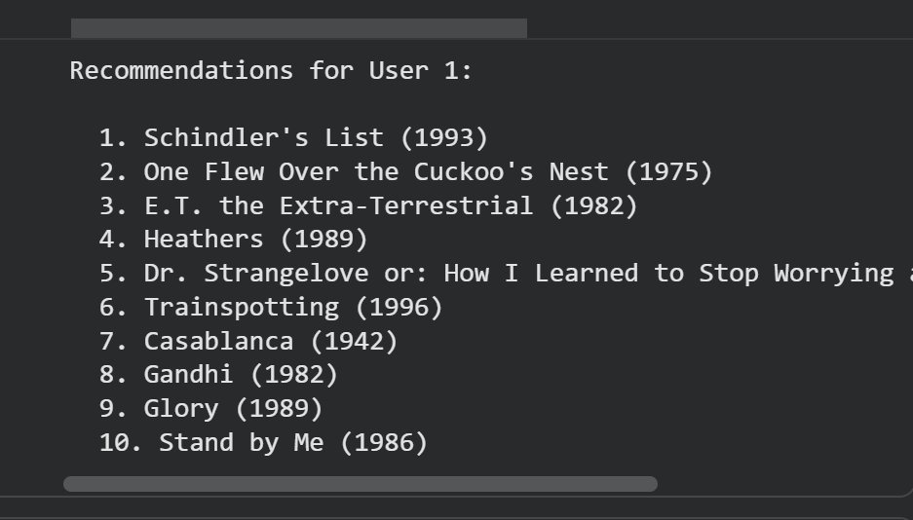
Figure 5: User-Based Collaborative Filtering — Top 10 Recommendations for User 1

4.3 Item-Based Collaborative Filtering
Item-based collaborative filtering compares movies by their rating patterns across all users rather than by genre. The user-movie matrix is transposed to produce a movie-user matrix, and cosine similarity is computed between all movie pairs. For a given user, the system identifies movies the user has rated, finds movies similar to those based on rating patterns, and scores candidates using a weighted sum of similarity scores multiplied by the user’s original ratings.
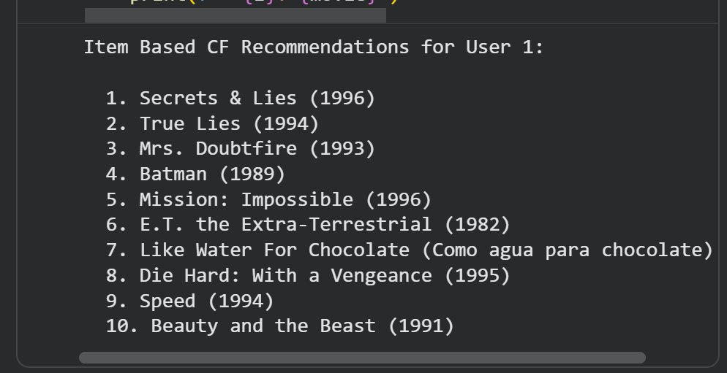
Figure 6: Item-Based Collaborative Filtering — Top 10 Recommendations for User 1

4.4 SVD (Singular Value Decomposition)
SVD is applied to the filled user-movie matrix using k=50 latent factors via scipy.sparse.linalg.svds. The decomposition produces three matrices (U, sigma, Vt) which are recombined to reconstruct a dense predicted rating matrix covering all user-movie combinations. For any given user, unseen movies are ranked by their predicted rating and the top results are returned.
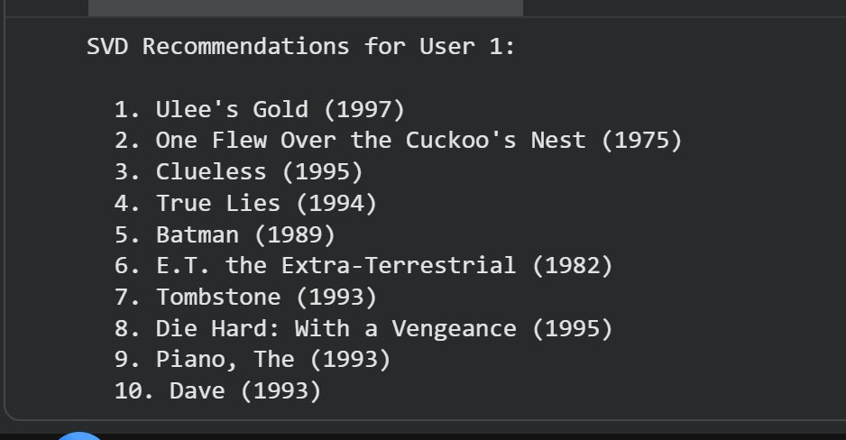
Figure 7: SVD Model — Top 10 Recommendations for User 1

4.5 Hybrid Model
The content-based and user-based collaborative filtering scores are combined using a weighted formula. Both score sets are normalized to the range [0, 1] before combining. The final score for each candidate movie is:
Hybrid Score = 0.6 × CF Score + 0.4 × Content Score
Movies the user has already rated are excluded from the final output. The top 10 scoring movies are returned.
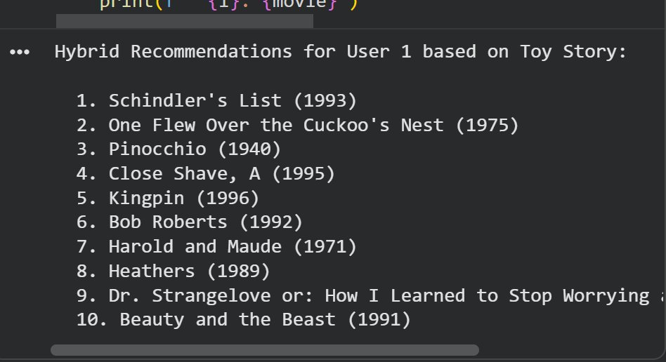
Figure 8: Hybrid Model Output — Top 10 Recommendations for User 1 Based on Toy Story (1995)

5. Evaluation

5.1 RMSE and MAE
For the collaborative filtering component, ratings were hidden for a sample of active users (those with at least 20 ratings), predictions were generated from the remaining data, and Root Mean Squared Error and Mean Absolute Error were computed against the held-out values.

5.2 Precision and Recall at K
For the SVD model, 20% of each user’s ratings were held out as a test set. Movies the user rated 4 or higher in the test set were treated as ground truth. The top K recommendations were checked against this set and precision and recall at K were computed.

Figure 9: Precision@10 and Recall@10 Results for the SVD Model

5.3 Hyperparameter Tuning
The number of similar users considered (K) was varied across values of 5, 10, 20, 30, and 50. RMSE was computed for each value on the first 30 active users. The value K=50 was selected for the deployed model based on these results.
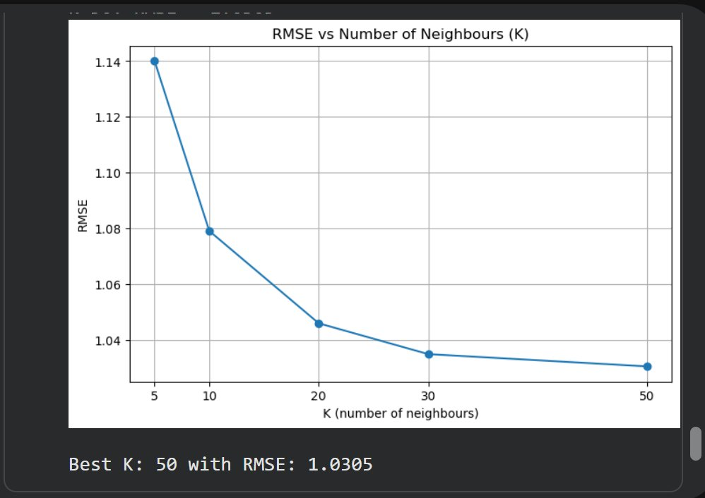
Figure 10: RMSE vs Number of Neighbours (K). Best K = 50 with RMSE = 1.0305

5.4 Results Summary

Metric | Result | Target
RMSE | 1.0305 | <= 1.1
MAE | 0.8518 | <= 0.90
Precision@10 | 0.5040 | >= 0.50
Recall@10 | 0.4901 | >= 0.45
Best K | 50 | Grid search tuned

6. Application Features
The Streamlit frontend provides two user-facing features:
- Get Recommendations: the user enters a user ID (1-943) and selects a movie they like. The hybrid model returns 10 personalized recommendations the user has not seen, displayed as a poster grid with TMDB ratings.
- Find Similar Movies: the user selects any movie and receives 10 genre-similar movies. This is not personalized and returns the same results for the same input regardless of user ID.

Movie posters and ratings are fetched from the TMDB API at query time using the movie title as a search query.
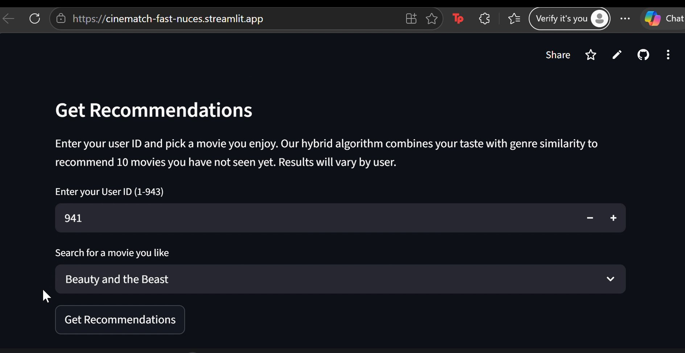
Figure 11: Get Recommendations Interface — User ID Input and Movie Selection
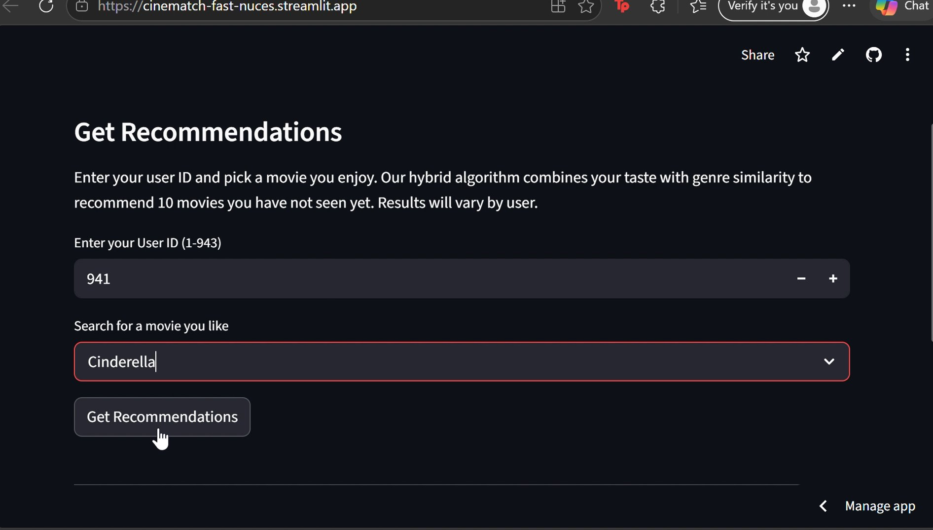
Figure 12: Personalized Recommendation Results Displayed as a Poster Grid with TMDB Ratings
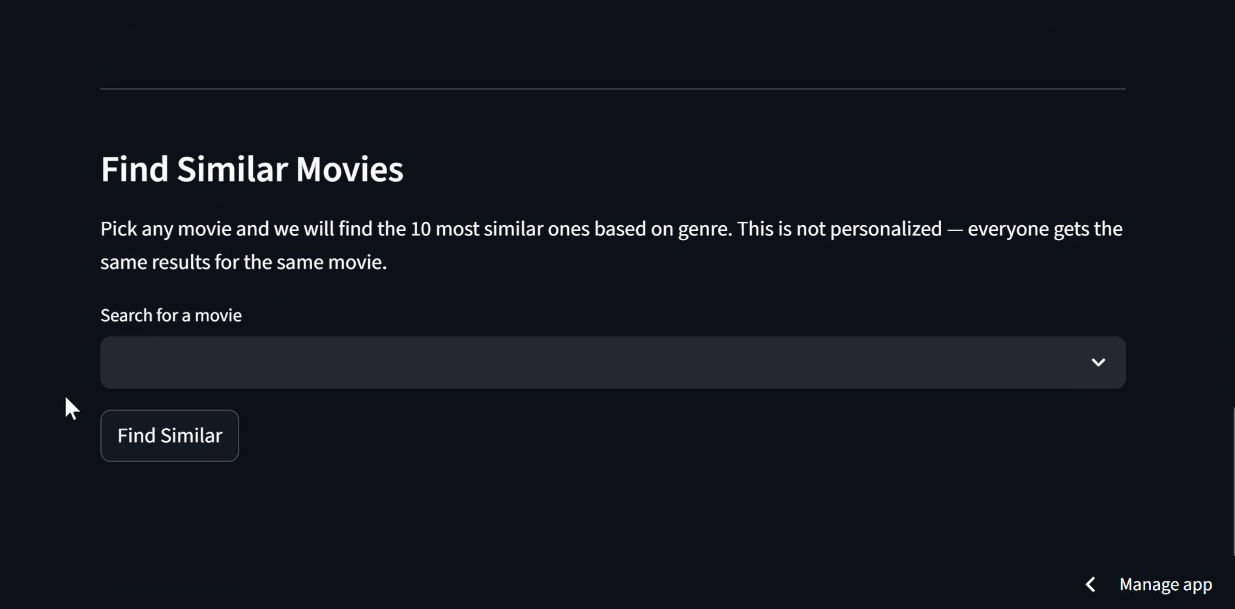
Figure 13: Find Similar Movies Interface — Genre-Based Search (Not Personalized)

Figure 14: Similar Movies Results for “Beauty and the Beast” — Genre-Similar Titles with Poster Art and TMDB Ratings

7. Technology Stack

Component | Technology
Dataset | MovieLens 100K
Model Training | Python, pandas, NumPy, scikit-learn, SciPy
Backend | FastAPI
Frontend | Streamlit
Poster / Rating API | TMDB API
Model Serialization | Python pickle
Deployment | Streamlit Community Cloud

8. Limitations
- The system only covers the 943 users present in the dataset. A new user with no ratings receives no collaborative filtering signal.
- Content-based filtering relies entirely on genre labels, so two movies with identical genres receive the same similarity score regardless of other attributes like cast or director.
- The frontend hardcodes the backend URL as localhost, which means the Streamlit Cloud deployment cannot reach the FastAPI server without a publicly accessible backend host.
- TMDB poster fetch relies on title string matching, which can return incorrect posters for movies with common or ambiguous names.

9. Conclusion
CineMatch demonstrates that combining genre-based content similarity with user-behavior collaborative filtering produces more useful recommendations than either method alone. The 60/40 weighting favors collaborative signals while using content similarity as a fallback for less-rated movies. The FastAPI and Streamlit stack allowed rapid prototyping with a clean separation between model logic and presentation. Future work could address the cold-start problem for new users, replace genre vectors with richer movie embeddings, and deploy the backend to a public server to make the full application accessible online.

